**Objective Questions**:

1. What is the total no. of tables present in the data?

* 2 tables present
  + Raw data
  + Country description

1. What is the total no. of attributes present in the data?

* 20 attributes in raw data
* 2 attributes in country description (country code is a common attribute present in both tables)

1. How many categorical columns are there in the data? [Search about categorical and continuous data, and try to answer this question]

* Categorical columns represent distinct groups, while continuous data refers to numerical columns (data that can be collected in decimals)
* The following columns are categorical:
  + Restaurant ID (unique ID which is not considered as a measure as we cannot apply calculations like sum, average on them)
  + Restaurant name
  + Country code (unique code for each country)
  + Country
  + City
  + Address
  + Locality
  + Locality/verbose
  + Cuisine
  + Has table booking
  + Has online delivery
  + Is delivering now
  + Switch to order menu

There are 13 categorical columns.

1. The data consists of some inconsistent and missing values so ensure that the data used for further analysis is cleaned

* 9 missing values in cuisines, deleted the null values

1. Using the Lookup functions, fill up the countries in the original data using the country code.

* Inserted in column D. (Used VLOOKUP)

1. Create a table to represent the number of restaurants opened in each country.

* Pivot table: Country name in rows and count of Restaurant ID in values.

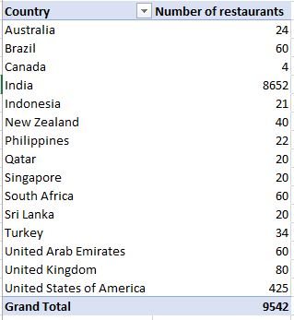

1. Also, the management wants to look at the number of restaurants opened each year, so provide them with something here.

* Created a new column ‘Year’ by extracting data from Datekey_opening
* Used LEFT() function on Datekey_opening
* Pivot table: Year in rows and count of Restaurant ID in values

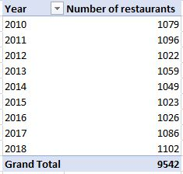

1. What is the total number of restaurants in India in the price range of 4?

* Pivot table: Country in filter🡪‘India’ selected, Price Range in rows🡪 ‘4’ in the filter, count of restaurant id in values.

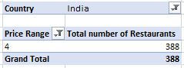

1. What is the average number of voters for the restaurants in each country according to the data?

* Pivot table: Country in rows and Average of Votes in values.

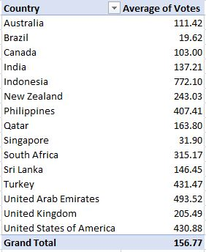

1. Calculate the average rating for all the restaurants that have price_range < 4 and provide online delivery. Use only the “IF” function, Logical Operators, and Aggregation functions to solve this problem. **[Note: Don’t use Conditional aggregation in this question.]**

* Used array function.



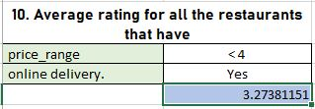

1. Using Conditional formatting highlight the rows of restaurants that are located in the countries or cities that you’ve suggested to the management for opening new restaurants.

* Pivot Table: Country in Rows, Count of restaurants in Values and Average ratings in values
* Applied Value filter to the Pivot table 🡪 filter by Top10 🡪 Bottom 5 items.
* This filters the table giving us the country names with the lowest number of Restaurants and average ratings of the country.
* 3 countries are suggested based the minimum number of restaurants in the country.

Small number of restaurants will imply a less competitive market and low ratings suggest for a better service and food quality.

* Applied filters on the Raw data table 🡪 filtered the country names to 3 suggested countries 🡪 applied fill colour to the filtered selection.

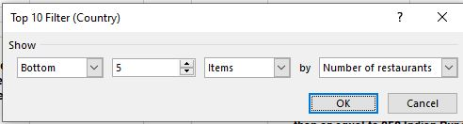

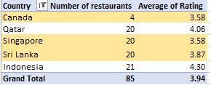

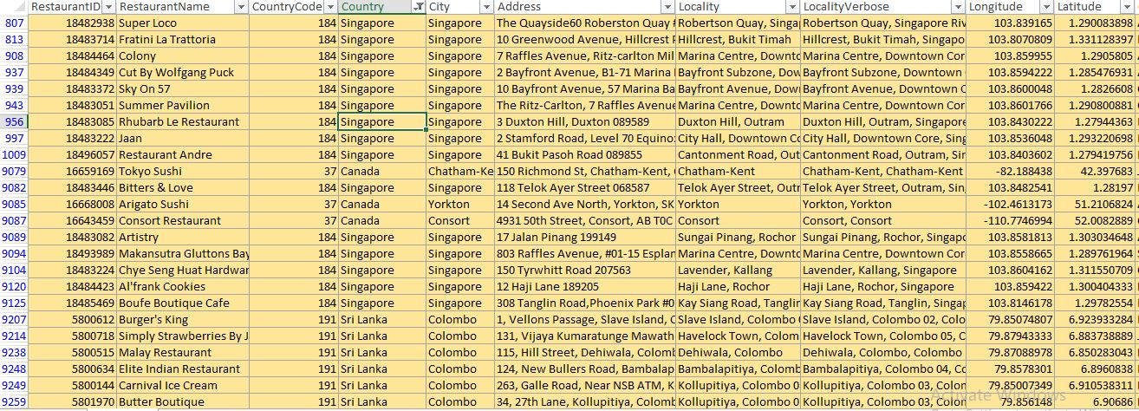

1. Create a new customized price column that consists of the abbreviation/symbol of the currency along with the Average_cost_for_two values. [Use string operations to do this task]

* Inserted in column T.



1. How can you create an array formula in Excel or Google Sheets to count the number of restaurants listed that do not offer online delivery, are in the lowest price range, and have an average cost for two people less than or equal to 250 Indian Rupees?



**Subjective Question:**

1. Suggest a few countries where the team can open newer restaurants with lesser competition. Which visualization/technique will you use here to justify the suggestions?

* Countries suggested for opening new restaurants are
  + Canada
  + Singapore
  + Sri Lanka

Among the suggested countries, Canada, Qatar, Singapore and Sri Lanka have the lowest number of restaurants along with average ratings. Opening newer restaurants in these would

Be beneficial as the competition is low.

**Approach:**

* + To open new restaurants, we consider the total number of restaurants available in each country and their average ratings.
  + Low number of restaurants may ensure low competition, while low ratings will communicate the quality of restaurants
  + We can see this by inserting a pivot table and a combo chart to get a quick read on the Data.

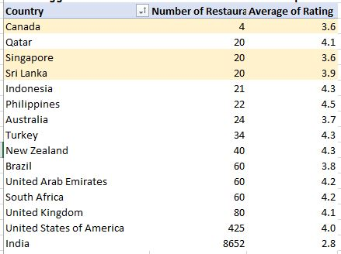 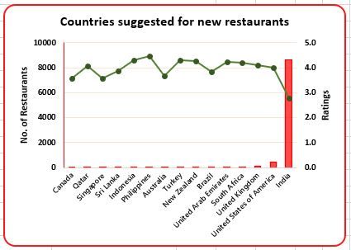

**Insight:**

* + From the pivot table, we can see that Canada, Singapore and Sri Lanka, all have low number of restaurants with average ratings.
  + From the combo chart, we can notice that India has the highest number of restaurants (about 90% restaurants are located in India.)

**Recommendation:**

* + It is suggested that the management look at the following countries for new restaurants:
    - Canada
    - Singapore
    - Sri Lanka
  + As these countries will provide an optimal environment for new openings; because of lower competition, management can focus on providing quality food and a better customer satisfaction to improve average ratings.
  + Although India has the lowest average ratings among all countries, it provides a highly competitive market.

1. Come up with the names of States and cities in the suggested countries suitable for opening restaurants.

**Approach:**

* Previously, we have shortlisted the countries where new restaurants can be opened. To further narrow down the selection, we look at which cities in the recommended countries to open our restaurants in.
* For this we create another pivot table with🡪 Country + City in Rows and Count of restaurants + Average ratings in Values. 🡪 Filter on country with the 3 recommended countries (Canada, Singapore and Sri Lanka) selected.

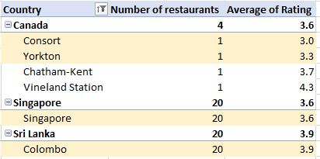

**Insight:**

* From the pivot table, we can see that Canada while having the lowest number of restaurants, the cities Consort and Yorkton have the lowest average ratings.
* Singapore and Sri Lanka have all their restaurants in only one city.
* Singapore although having the same number of restaurants as Sri Lanka is still lower in terms of average ratings.

**Recommendation:**

* Consort and Yorkton in Canada provide an optimal environment for opening of a new restaurant as they both have only one restaurant under Zomato and also have the lowest average rating among others.
* Singapore has 20 restaurants with an average of 3.6 ratings. Focus on quality of food and providing good customer services should also be given when opening a new restaurant.
* Colombo, Sri Lanka also has 20 restaurants in total with ratings of 3.9.
* Opening new restaurants in these location would be a great opportunity as there will be low competition and managers can focus more on the customer satisfaction and quality.

1. According to the countries you suggested, what is the current quality regarding ratings for restaurants that are open there?

**Approach:**

* As ratings was assumed as one of the important metrics to take into account. We have inserted average ratings along with the number restaurants to analyse which location would be more suitable for new restaurants.
* We can see in the pivot table with🡪 Country + City in Rows and Count of restaurants + Average ratings in Values. 🡪 Filter on country with the 3 recommended countries (Canada, Singapore and Sri Lanka) selected.



**Insight:**

* Canada has an average rating of 3.6. Singapore also with 3.6 ratings. Sri Lanka has an average rating of 3.9.
* Although, Singapore has the same number of restaurants as Sri Lanka is still lower in terms of average ratings.

**Recommendation:**

* Consort and Yorkton in Canada can provide a good opportunity for new restaurants. There is very less competition as there is only 1 restaurant per city under Zomato along with average ratings below 3.5. This is a good indicator to open a new restaurant with quality food and services.
* Singapore and Sri Lanka both have only one city under Zomato. Both have 20 restaurants with average ratings between 3.5-4. Management can look for opportunities of new restaurants in different cities as well while focusing on improving the quality and services of the existing restaurants.
* Alternatively, if the focus is of opening new restaurants in the existing cities under Zomato. Management can look for opening cuisine specific restaurants to counter competition and focus on giving quality food of the specific cuisine.

1. Also, what is the current expenditure on food in the suggested countries, so we can keep our financial expenditure in control?

**Approach:**

* Our raw data consists of multiple currencies. To understand current financial expenses of the countries, we first convert all the prices to one currency.
* After converting all the currency values to their value in INR. We use Pivot table to get a quick read of the average of average cost for two.
* Pivot table🡪 Country in rows (filter on the suggested countries) 🡪 Average cost for two in INR in Values

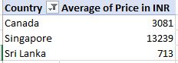 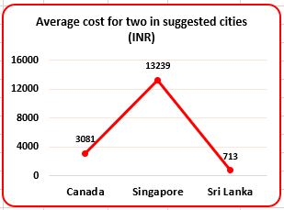

**Insights:**

* Canada having only 4 restaurants with an average cost of 3081INR, indicates a good opportunity for growth because of low competition and an economical pricing.
* Singapore has the highest average cost amounting up to 13,239INR. This indicates that customers are willing to spend.
* Sri Lanka has the lowest average cost among the suggested countries. This may indicate that people are more budget-conscious.

**Recommendations:**

* Canada shows a significant opportunity for new restaurants because of the less competitive market along with economical expenditure. Expanding here will give us a strong opportunity to capture a good customer base.
* In Singapore, people are willing to spend more. Offering good quality of food and services will further help improving the customer relations. As mentioned before, offering cuisine specific restaurant with a high focus on quality of food and a good dining experience will gain us a good advantage to capture the market despite the high competition.
* As customers are more budget conscious in Sri Lanka, focus on budget friendly restaurant is essential. Offering discounts or combo deals may help in attracting more customers.

1. Come up with the names of restaurants from the recommended states that are our biggest competitors and also those that are rated in the lower brackets, i.e., 1-2 or 2-3.

**Approach:**

* As ratings was assumed as one of the important metrics to take into account. We have inserted average ratings along with the number restaurants to analyse which location would be more suitable for new restaurants.
* We can see in the pivot table with🡪 Country + City in Rows and Count of restaurants + Average ratings in Values. 🡪 Filter on country with the 3 recommended countries (Canada, Singapore and Sri Lanka) selected. Value filter on Top10 restaurants with respect to ratings.
* Similar pivot table is created for low rated restaurants, with a filter on ratings (1-2 and 2-3) is applied.

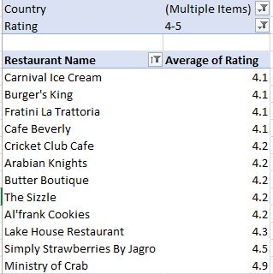 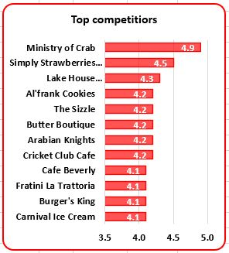

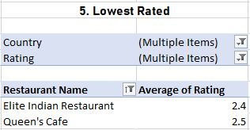 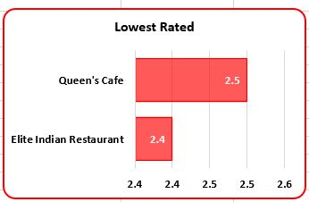

**Insights:**

* Pivot for both top competitors and lowest rated can be filtered to further narrow down which restaurants are located in the desired country.
* Out of the top 10 competitors.
  + Lake house Restaurant in located in Canada.
  + Fratini La Trattoria and Al'frank Cookies are located in Singapore
  + And the rest 7 restaurants are located in Sri Lanka
* There are only 2 restaurants that fall under the rating bracket between 1-3. Both these restaurants are located in Sri Lanka. While restaurants in Canada and Singapore have all their restaurants in the rating bracket of 3-5.

**Recommendations:**

* Canada has only 1 restaurant that is a top competitor with 4.3 ratings. There are 3 more restaurants that fall below the rating of 4. Opening a restaurant in other cities where the rating is lower will provide a better opportunity for growth. Alternatively, opening a restaurant with a different cuisine than what Lake house is offering can be beneficial and attract a new clientele along with the existing one.
* Despite having 20 restaurants only 2 are in the top ratings. From the average costing we saw that people are willing to spend in Singapore. A focus on providing good quality and a quality experience is needed in Singapore.
* Sri Lanka has the highest number of restaurants rating above 4. But it also has the lowest rated restaurants among the suggested countries. This indicates that there is a clientele that is willing to spend on restaurants. Focus on providing a quality and unique experience will definitely help capture a larger market and improve the average cost.

1. Which cuisines should we focus on in the newer restaurants to get better feedback? Does the choice of cuisines affect the restaurant ratings?

**Approach:**

* To understand which cuisine we should focus on. We can see the least rated cuisines in the suggested countries.
* Pivot table 🡪 Cuisine in rows 🡪 Selected countries in columns 🡪 Average ratings in values.
* Value filter on bottom 10 cuisines with respect to ratings is also applied.

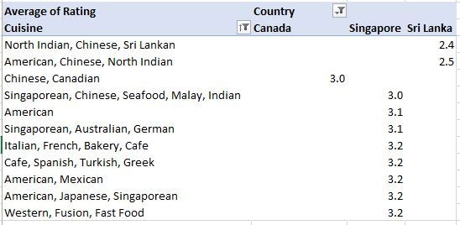

**Insights:**

* Our restaurant in Canada serving Chinese and Canadian cuisine is only receiving average ratings.
* Sri Lanka has lowest ratings among the suggested countries with mostly multi-cuisine restaurants.
* Singapore is receiving average ratings in almost all the cuisines available. We can see that the cuisines under Singapore are from all around the world and still rating between 3-3.5.

**Recommendation:**

* In Canada, Chinese and Canadian cuisine are rated low. Focus in providing authentic Chinese cuisine with a unique dining experience will help capture the market.
* Sri Lanka is rating low in Asian cuisines. This can be because of poor dining experience or poor quality of food.
* Similarly, Singapore is rating average in all global cuisines. Dining experience and authentic food should be given more importance.
* Singapore and Sri Lanka, both have multi-cuisine restaurants. Which while providing a wide variety of items in the menu are lacking in proving good quality. We can see that both these countries have wider palates, reducing the items on the menu and ensuring good and authentic dishes will be beneficial.

1. According to our current data, should we go for online delivery and table booking? Does that affect the customer’s ratings?

**Approach:**

* Pivot Table🡪’Has_online_delivery’ in rows🡪’Average rating in values.
* Similarly, Pivot Table🡪’Has_table_booking’ in rows🡪’Average rating in values.

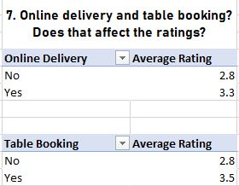

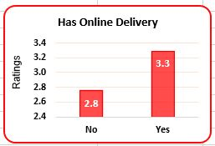 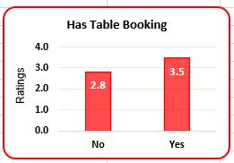

**Insights:**

* Restaurants with online delivery have a higher average rating compared to others. This suggests that offering online delivery services can enhance customer satisfaction and overall ratings.
* Similarly, restaurants that provide table booking options have a higher average rating compared to those that don’t. This indicates that customers value the convenience of reserving a table.

**Recommendations:**

* It is evident in the charts that restaurants that provide online deliveries and table bookings receive a higher rating than those that don’t.
* Considering this it is recommended to provide delivery options with the help of popular delivery platforms and offer table booking through websites or apps. Not only in new restaurants but also in existing ones. Implementing these features across all locations can improve customer satisfaction and the overall ratings.

1. Should the team keep the rate of cuisines higher? Will that affect the feedback? According to our data are the rates of cuisines and ratings, correlated?

**Approach:**

* Pivot Table🡪Cuisine in Rows 🡪 Average Rating and Average of Price in INR in Values.

Top 15 by Average of Price in INR in Value filter.

* A combination chart is used to corelate the metrics.

X-axis = Cuisine

Y-axis = Average of Price in INR (represented in columns)

Secondary Y-axis = Average Ratings (represented with line)

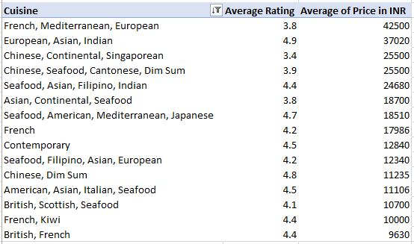

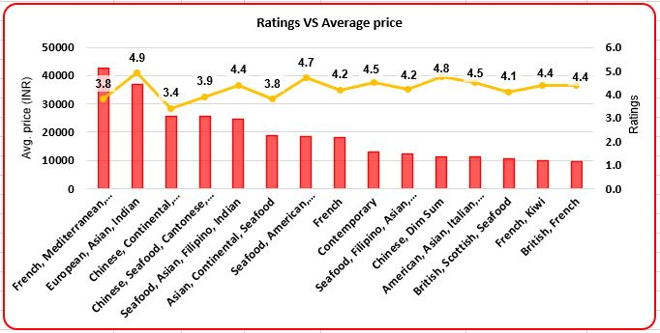

**Insights:**

* Cuisine "European, Asian, Indian" with a rating of 4.9, has an average cost of 37,020 INR. While, "Chinese, Dim Sum" has a high rating of 4.8 but a much lower cost of 11,235 INR.
* There are restaurants that are rated high yet have a moderate average cost e.g., “Chinese, Dim sum” with a rating of 4.8 and an average cost of 11,235 INR.
* And some that have low ratings yet very high average cost e.g., "French, Mediterranean, European" has a lower rating of 3.8, yet has the highest average cost of 42,500 INR.

**Recommendations:**

* As we can see, there is no corelation between ratings and average cost of the restaurant.
* High ratings can be found at various price points, this indicates that there are other factors that play a significant role in determining the ratings and customer satisfaction.

1. What is the distribution of the number of restaurants of different price ranges in all the countries?

**Approach:**

* Pivot Table🡪’Price range’ in rows🡪’Count of RestaurantID’ in values.

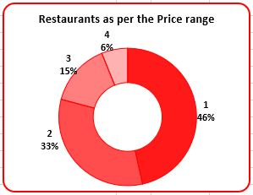 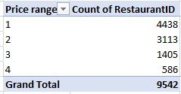

**Insights:**

* As evident in the Chart and pivot table, majority of the restaurants (4438 or 46%) fall under the price range of 1. This indicates that most restaurants offer affordable dining experience.
* And only 586 restaurants or 6% are in the price range of 4.
* Number of restaurants gradually reduce as the price range increases. Which may be because of high cost.

**Recommendations:**

* Opening restaurants in the price range of 1-2 would help us attract a large clientele since we know that majority of the market is between these ranges.
* Opening restaurants in higher price range like 3-4 would cater to a small audience, offering unique and special dining experience with good quality food may help attract this clientele as they are willing to pay for better experience.

1. Explain your approach in brief for suggesting countries/cities in order to open new restaurants, if the objective and subjective questions would have not been given to assist you. **[you have to give bullet pointers in order to answer this question]**

* For understanding which countries/cities to open new restaurants in first we need to understand the metrics that are available
* There are two broad metrics that were considered: Number of restaurants available in the country and the ratings.
* With lower number of restaurants available, the competition would be less and management can focus on other decisions like cuisine, quality, availing online delivery and table bookings.
* With respect to lower ratings, opening restaurants that guarantee good quality of food and better customer services alongside working to improve the ratings of the existing restaurants.

**The dashboard must consist of Year-wise and country slicers.**